|  |  |  |
| --- | --- | --- |
| Дата 21.05.2025 | **ЯСЛИ** | |
| Завтрак | Гр | Ккал |
| Масло сливочное | 5 | 33,05 |
| Омлет натуральный | 150 | 260 |
| Кофейный напиток с молоком | 150 | 87,85 |
| Хлеб пшеничный | 30 | 70,5 |
| Второй Завтрак |  |  |
| Яблоки | 150/1 шт | 51,6 |
| Обед |  |  |
| Свекольник с мясом и сметаной | 150/5/6,5 | 96,7 |
| Жаркое по-домашнему | 180 | 245,1 |
| Отвар шиповника | 150 | 46,84 |
| Хлеб ржаной | 40 | 69,9 |
| Полдник |  |  |
| Сдоба обыкновенная | 40 | 121,22 |
| Снежок | 160 | 126,4 |
| Ужин |  |  |
| Салат из морской капусты Клюковка | 40 | 30,4 |
| Запеканка из печени с рисом | 60 | 119 |
| Чай полусладкий с лимоном | 150/5 | 23,14 |
| Хлеб пшеничный | 30 | 70,5 |
| Заведующий МБДОУ «Детский сад 238» Сепп М.А. |  |  |

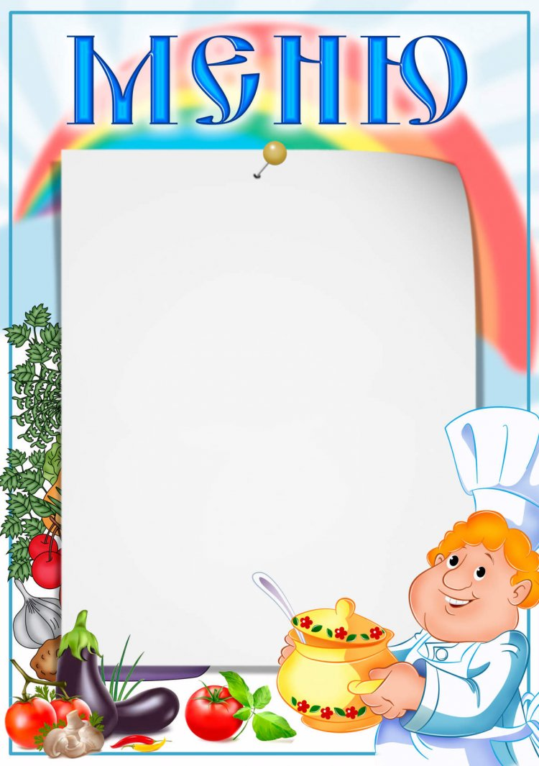

|  |  |  |  |  |  |  |  |  |  |  |  |  |  |  |  |  |  |  |  |  |  |  |  |  |  |  |  |  |  |  |  |  |  |  |  |  |  |  |  |  |  |  |  |  |  |  |  |  |  |  |  |  |  |  |  |  |  |  |  |  |  |  |  |  |  |  |  |  |  |  |  |  |  |  |  |  |  |
| --- | --- | --- | --- | --- | --- | --- | --- | --- | --- | --- | --- | --- | --- | --- | --- | --- | --- | --- | --- | --- | --- | --- | --- | --- | --- | --- | --- | --- | --- | --- | --- | --- | --- | --- | --- | --- | --- | --- | --- | --- | --- | --- | --- | --- | --- | --- | --- | --- | --- | --- | --- | --- | --- | --- | --- | --- | --- | --- | --- | --- | --- | --- | --- | --- | --- | --- | --- | --- | --- | --- | --- | --- | --- | --- | --- | --- | --- |
| |  |  |  | | --- | --- | --- | | Дата 21.05.2025 | **САД** | | | Завтрак | Гр | Ккал | | Масло сливочное | 5 | 33,05 | | Омлет натуральный | 200 | 346,7 | | Кофейный напиток с молоком | 200 | 101,8 | | Хлеб пшеничный | 40 | 94 | | Второй Завтрак |  |  | | Яблоки  Напиток витаминный | 150/1 шт  200 | 51,6  74 | | Обед |  |  | | Свекольник с мясом и сметаной | 200/5/6,7 | 106,7 | | Жаркое по-домашнему | 200 | 272,3 | | Отвар шиповника | 200 | 53,52 | | Хлеб ржаной | 51,9 | 87,39 | | Полдник |  |  | | Сдоба обыкновенная | 50 | 144,2 | | Снежок | 197 | 158 | | Ужин |  |  | | Салат из морской капусты Клюковка | 80 | 60,8 | | Запеканка из печени с рисом | 180 | 324,3 | | Чай полусладкий с лимоном | 200/7 | 34,3 | | Хлеб пшеничный | 40 | 94 | |  |  |  | |  |  |  | | | | | | | | | |
| Заведующий МБДОУ «Детский сад 238» Сепп М.А. | |  | |  | |  | |  |
|  | |  | |  | |  | |  |
|  | |  | |  | |  | |  |
|  | |  | |  | |  | |  |
|  | |  | |  | |  | |  |
|  | |  | |  | |  | |  |
|  | |  | |  | |  | |  |
|  | |  | |  | |  | |  |
|  | |  | |  | |  | |  |
|  | |  | |  | |  | |  |
|  | | | | | | | | |
|  |  | | | |  | | | |
|  |  | |  | |  | |  | |
|  |  | |  | |  | |  | |
|  |  | |  | |  | |  | |
|  |  | |  | |  | |  | |
|  |  | |  | |  | |  | |
|  |  | |  | |  | |  | |
|  |  | |  | |  | |  | |
|  |  | |  | |  | |  | |
|  |  | |  | |  | |  | |
|  |  | |  | |  | |  | |
|  |  | |  | |  | |  | |
|  |  | |  | |  | |  | |
|  |  | |  | |  | |  | |
|  |  | |  | |  | |  | |
|  |  | |  | |  | |  | |
|  |  | |  | |  | |  | |
|  |  | |  | |  | |  | |
|  |  | |  | |  | |  | |
|  |  | |  | |  | |  | |
|  |  | |  | |  | |  | |
|  |  | |  | |  | |  | |
|  |  | |  | |  | |  | |
|  | | | | | | | | |